THE HOME FRONT: WORLD WAR II IN AMERICA

A SEGREGATED MILITARY

As the United States began to mobilize for the war against Germany and Japan, General George C. Marshall was put in charge of the largest expansion of our military in American history. The US passed the Selective Training and Service Act- the draft the army grew from less than 190,000 in 1939 to over 12 million by the war’s end!
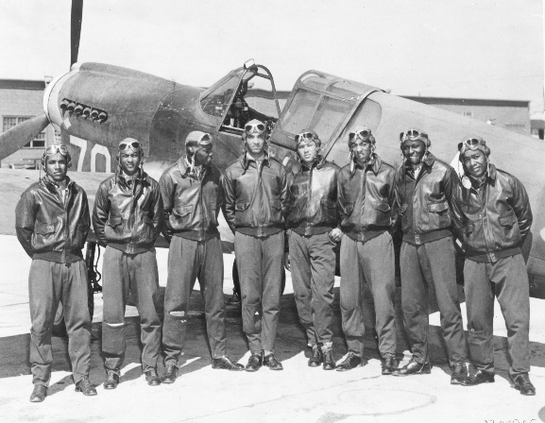
Although training stressed the importance of unity, the US army was still very segregated (blacks and whites were not allowed to be in same squadron).
In 1941, the air force created its first African-American unit, the 99th Pursuit Squadron. Trained in Tuskegee, Alabama, the pilots became known as the Tuskegee Airmen. These squadrons flew over 200 missions without ever losing a single member to an enemy aircraft. Other segregated African-American units, such as the 761st Tank Battalion were commended for their bravery during the Battle of the Bulge.
About one-third of all Native American men served in the military during the war. More than 400 Navajo Marines served as “Code Talkers,” relaying critical information and orders over field radios coded in their own native language. The Navajo code is the only military code to never have been broken.
Although women were barred from combat, they served in the armed forces doing clerical and administrative work. Congress first allowed women in the military in 1942 by creating the Women’s Army Auxiliary Corps (WAAC) and the Women’s Army Corps (WAC). About 300 women served as Women Airforce Service Pilots (WASPs) and flew more than 12,000 flights across the Atlantic Ocean to deliver planes to the war effort.

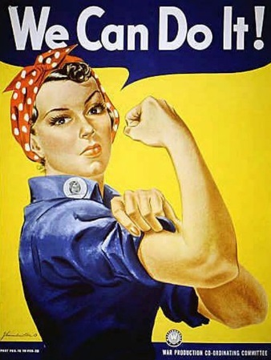
OPPORTUNITIES ON THE HOMEFRONT

World War II was a time of opportunity for many Americans. The economy boomed. There were plenty of jobs. Wages rose. Farmers also did well.
Women had many job opportunities during the war. The US launched a huge propaganda campaign to encourage women to enter the workforce, including the famous Rosie the Riveter “We Can Do It!” poster. The share of women in the work force rose to 35 percent. (They lost some of these jobs when the men returned from military service.)
War production increased rapidly after Pearl Harbor. By Summer of 1942 almost all major industries and some 200,000 companies had converted to war production. Automobile plants began making tanks, jeeps, trucks, rifles, helmets, and artillery. Mass production of these resources would help to win the war.
In 1944, Congress passed the GI Bill of Rights, which was designed to help servicemen readjust to civilian life. This bill paid for veterans to attend college or technical school. Over half the returning soldiers took advantage of this opportunity. It also gave loans to veterans buying homes or starting businesses. The GI Bill gave many people opportunities they otherwise would never have had.

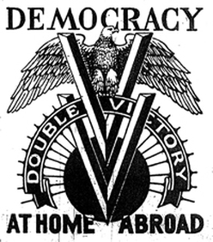
DISCRIMINATION AND REACTION

On the home front, many African Americans left the South and moved to the West Coast. There they found skilled jobs that paid well. But they also found prejudice. In 1942, civil rights leader James Farmer formed a new interracial organization to fight discrimination. It was called the Congress of Racial Equality (CORE).
The NAACP launched what it called the “Double V” campaign to urge African Americans to support the war to win a double victory over Hitler’s racism abroad and racism at home in the US.
African Americans also moved into the crowded cities of the North. Tension among the races grew. In 1943 it led to race riots. The worst one was in Detroit, where over 30 people were killed. President Roosevelt had to send federal troops to restore order. In response, many communities formed committees to improve race relations.
Mexican Americans experienced prejudice during the war years as well. In 1942, there were anti-Mexican riots in Los Angeles. In the “zoot-suit” riots, Mexican Americans were beaten by white service men and civilians.
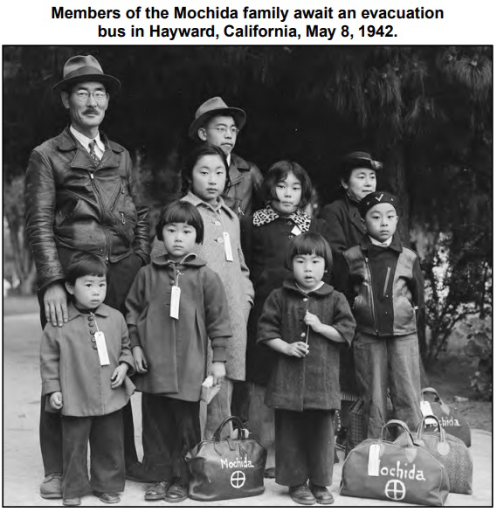
INTERNMENT OF JAPANESE AMERICANS

Japanese Americans endured terrible treatment during the war. After Pearl Harbor, panic-stricken Americans believed Japanese Americans living in the U.S. were disloyal to the United States.
On February 19, 1942, President Roosevelt ordered the internment of all Japanese Americans living in California, and other western states. More than 100,000 people were rounded up and shipped to internment camps. Many lost their businesses, jobs, and homes.
No charges were ever filed against Japanese Americans. No evidence of subversion was ever found. In 1944, in the case of Korematsu v. United States, the Supreme Court said the government policy was justified by “military necessity.”
KOREMATSU v. UNITED STATES, 1944____________
Background of the Case
Executive Order 9066 gave the military the power to exclude people of Japanese descent from areas that were deemed important to U.S. national defense and security. In 1942 Toyosaburo Korematsu refused to leave San Leandro, California. Korematsu petitioned the Supreme Court to review the federal court's decision.
How the Court Ruled
In their decision (6-3) found that, although exclusion orders based on race are constitutionally suspect, the government is justified in time of "emergency and peril" to suspend citizens' civil rights.

VICTORY GARDENS, RATIONING, AND SCRAP DRIVES

During WWII, many resources were in short supply because everything was needed to support the war effort. Americans faced shortages of paper, metals, oil, and nylon—just about anything you can think of. Americans were encouraged to carpool and make do without buying new clothing. Food was also on the list of commodities that needed to be shared between civilians and the military.
The U.S. government issued ration books that limited the amounts of items Americans could purchase, including meats, butter, eggs, oil, dry beans, frozen vegetables, milk, and ketchup. Ration books helped conserve food, but also prevented wealthy Americans from buying up scarce food supplies.
As part of the food conservation efforts, the government urged Americans to plant Victory Gardens, where they could grow fruits and vegetables to help feed family and friends. Over 20 million gardens were planted—in back yards, vacant lots, on baseball diamonds, and even on rooftops. To encourage the planting of Victory Gardens, propaganda posters reminded people that their gardens not only provided food, but also were a key component of the war effort.
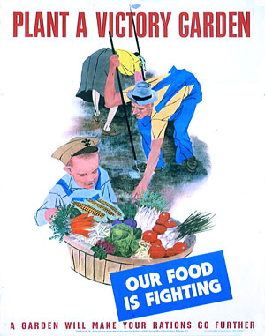
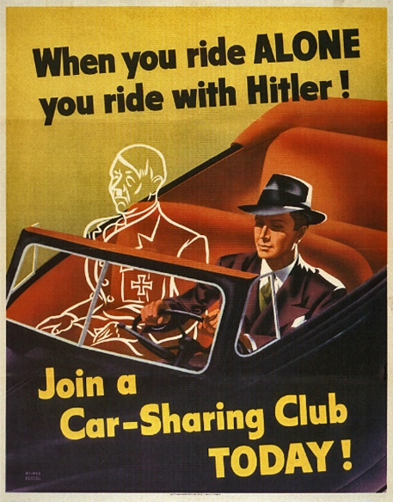
Scrap drives enabled people to donate common household items needed for the war effort. These items included shoes, rubber, gasoline, silk, nylon, and even shellac. People would bring their donations to scrap-drive locations located throughout cities and towns.
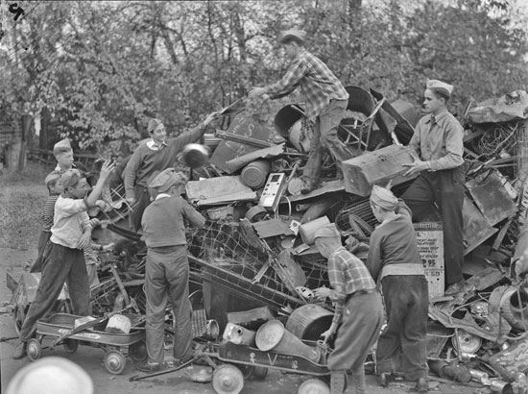

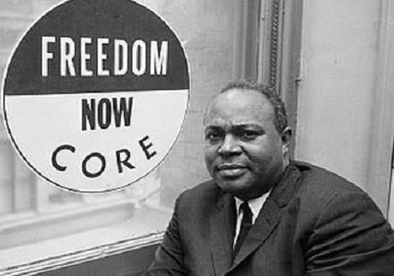
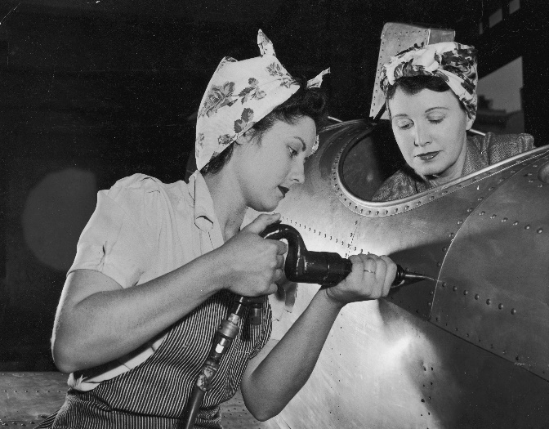
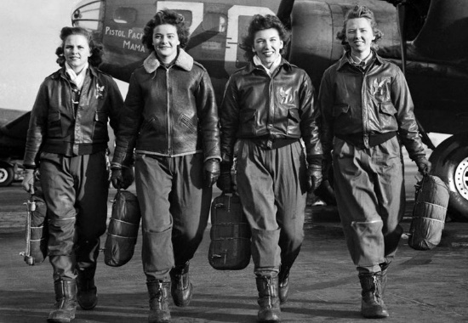
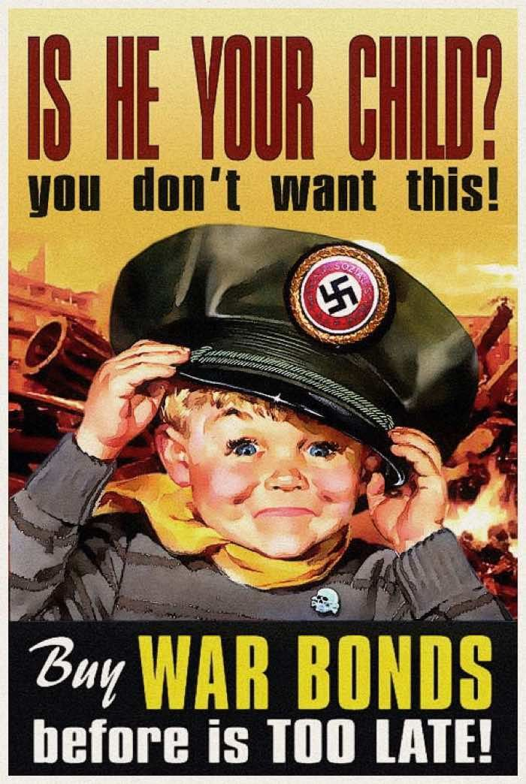
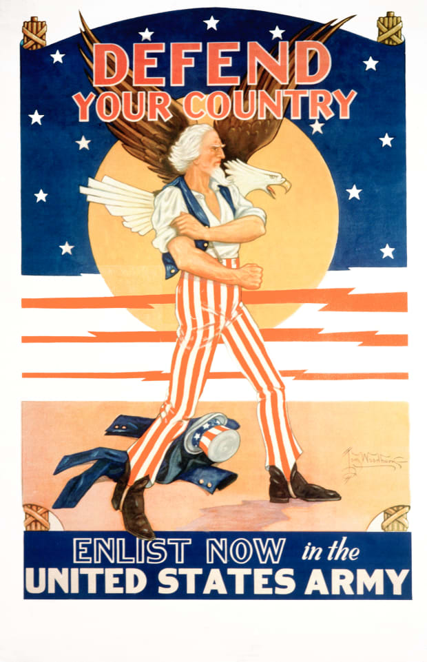
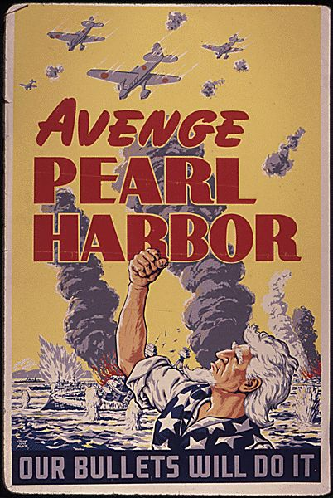
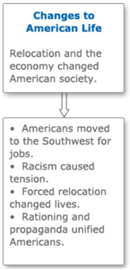
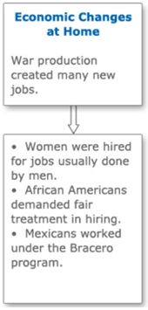
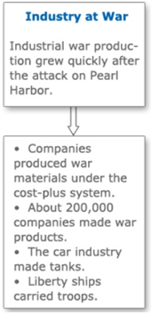
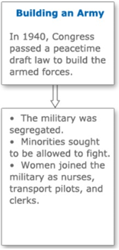
James Farmer founded CORE
The Real Rosie the Riveter
WASPS in WWII
