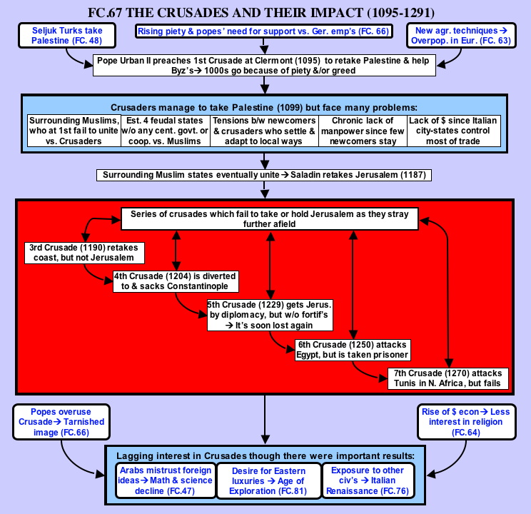
The Crusades & their impact (1095-1291)
...But these were small matters compared to what happened at the temple of Solomon, a place where religious services are ordinarily chanted. What happened there? If I tell the truth, it will exceed your powers of belief. So let it suffice to say this much at least, that in the temple and portico of Solomon, men rode in blood up to their knees and bridle reins. Indeed, it was a just and splendid judgment of God, that this place should be filled with the blood of the unbelievers, when it had suffered so long from their blasphemies. — Foucher de Chartres
The First Crusade (1095-99)
The modern reader (both Christian and non-Christian) is justifiably shocked at how medieval Christians such as Foucher de Chartres exulted in the wholesale butchery that took place in Jerusalem, the holiest city of Christianity, to end the religious war known as the First Crusade. However, that description expresses quite well not just the rough edge of medieval Christian faith, but also the power and energy that, for nearly two centuries, drove Europeans to launch the Crusades in order to conquer and hold Palestine. There were several reasons for the Crusades happening when they did.
First of all, there was the expanding power of Western Europe in the eleventh century. More settled conditions plus better agricultural techniques helped trigger population expansion that created large numbers of landless younger sons of nobles. Adding to these pressures was a series of bad harvests providing an even greater incentive to find land elsewhere. While the Crusades were the most dramatic and publicized example of Europe's expanding frontiers, there was similar expansion by Spanish Christians in Spain, by the Normans in Southern Italy and Sicily, and by the Germans in Eastern Europe.
The most immediate reason centered on events in the Middle East. In the eleventh century, a new people, the Seljuk Turks, replaced the Arabs as the dominant power in the Islamic world, overrunning most of Asia Minor after crushing the Byzantine army at Manzikert (1071) and seizing Palestine from the Shiite Fatimids of Egypt. These conquests led to pleas to the West for help, both from Christian pilgrims to Palestine who suffered from mistreatment at the hands of the Turks and from the Byzantine emperor, Alexius I, who just wanted mercenaries with which he could reconquer Asia Minor. As an added enticement, Alexius held out the possibility of reuniting the Greek Orthodox and Roman Catholic Churches, which had been split since the schism of 1054.
The rising power of the Church at this time was another factor leading to the Crusades. This created a rising tide of piety in Western Europe that expressed itself in pilgrimages to Palestine before the Turks seized it, and adapted itself to a holy war (crusade) after the Turkish conquest. This rising tide of piety was part of a broader movement for Church reform led by the popes that had caused the Investiture Struggle with the German emperors over control of the election of Church officials. Both the reunification of the Catholic Church with Byzantium and the recovery of Jerusalem fit into the larger ambitions of Pope Urban II. If the pope could lead all of Christendom in a crusade to recover the Holy Land (Palestine), then his moral authority would far surpass that of the German Emperor. Therefore, in 1095, at the French town of Clermont, Pope Urban II preached the First Crusade (from the Latin word, crux, for cross) to liberate the Holy Land from the Turks. Apparently his speech struck a nerve, because thousands enthusiastically "took the cross" (i.e., vowed to go on crusade).
This raises the question of what spurred the rank and file of Europe to undertake such a long and dangerous journey. Two main factors present themselves: piety and poverty. Piety should never be downplayed in the Middle Ages, although the nature of medieval piety may have been somewhat different from our own concept of it. Crusaders went to the Holy Land believing that such a journey and the killing of non-Christians in defense of the faith would earn them forgiveness for their sins. Poverty and greed also played their role. As we have seen, Europe's expanding population created a large number of landless younger sons of nobles. Going on crusade offered them both the opportunity to win such lands and forgiveness for their sins as well. No wonder so many of them decided to undertake such a long and dangerous enterprise.
Most of those who went were nobles who needed time to get supplies for their journey and set their personal affairs in order before leaving. Therefore the departure of the First Crusade was set for August 1096 from Constantinople. This would also give the Byzantines time to prepare supplies along the line of march.
However, there were also many desperately poor peasants who had no substantial affairs to set in order. Therefore, they just set off for the Holy Land without making any plans or provisions for the march. These undisciplined mobs, known collectively as the Peasants' Crusade, gained followers and momentum in each village through which they passed. Their growing numbers also created ever mounting supply problems that often erupted into violence as they turned to pillaging for food. Such violence was often turned against local Jews, since they were non-Christian and this was a "holy war" to begin with. As a result, thousands of Jews were either killed or forced to flee their homes. However, the Jews were not the only ones upset by these peasant groups, and local populations and rulers would often turn against these unwelcome intruders. For example, three waves of peasants who went through Hungary were each destroyed by the Hungarians who were tired of their plundering.
Those who made it to the Byzantine Empire fared no better. Many were picked off on their foraging raids by Byzantine cavalry. The rest were quickly ferried across to Asia Minor to prevent further trouble in Constantinople. Not trusting the Byzantines, this undisciplined mob ignored Alexius’ advice to stay by the coast and Byzantine support. As a result, the Turks annihilated all but a few of them.
The more organized and disciplined crusading knights and nobles made their way to Constantinople in isolated groups. This allowed the emperor to deal with them singly, impressing them with his collection of relics and mechanical wonders and then extracting an oath from them to turn over any lands formerly held by the Byzantines. He would then shuttle them across to Asia Minor in time to meet the next group of crusaders arriving in Constantinople and repeat the process. These measures did help Alexius recover part of Asia Minor, notably the city of Nicaea, but they also added to growing tensions with the Crusaders who felt they were the victims of Byzantine trickery.
The crusaders saw their first serious fighting in Asia Minor. Helped by both the turmoil caused by the Assassins' murder of Malik Shah and the Turks' expectation that these European knights would be as easy a prey as the Peasants' Crusade had been, the crusaders' heavily armored shock cavalry defeated the Turks in their first major encounter. The crusaders themselves were frustrated by the Turks' mobile hit and run tactics that made it hard to win a decisive victory over them. Despite this and the intense heat, the crusaders fought their way across Asia Minor.
While the rest of the crusaders pressed into Syria, one of their leaders, Baldwin, carved out his own state around the city of Edessa using only 80 knights and some skillful diplomacy and intrigue. Naturally, this spurred the ambitions of other crusaders, in particular a Norman knight named Bohemond who had his eyes set on Antioch, one of Syria's premier cities. Antioch fell after a long grueling siege, thanks largely to the intrigues of Bohemond who then claimed the city as his own. This was the second of the crusader states to be founded as well as the source of a good deal of jealousy and quarrelling among the various crusader leaders.
The eight-month siege and stay at Antioch had decimated the Christian army through disease, hunger, and battles against various Muslim armies sent to relieve Antioch. Add to this the constant bickering between its leaders and the polyglot mixture of French, English, Germans, and Italians making up the army, and the chances of continued success did not look good. However, the rank and file in the army insisted on putting aside their quarrels and marching on Jerusalem. Finally, in June 1099, with an army of only 15,000 men, they reached their long sought goal, Jerusalem.
The crusaders endured desert heat and shortages of food and water while besieging Jerusalem. They also faced the threat of a large Egyptian army coming to relieve the city. Luckily, an Italian fleet arrived at the harbor of Jaffa, bringing the crusaders supplies and timber for siege engines. After doing penance by marching barefoot in the desert heat around Jerusalem, the crusaders launched an assault that broke into the city on July 15. What ensued was one of the worst massacres in history, spurred on by religious frenzy combined with frustration from the hardships of the last three years. Foucher de Chartres' graphic description at the top of this reading shows how the crusaders used religion to justify this ghastly event. The success of the First Crusade was a remarkable feat, but it was stained with the blood of thousands of innocent Muslims and Jews.
The Kingdom of Jerusalem (1099-1187)
Despite their incredible victory, the crusaders had much going against them. First of all, they were surrounded and outnumbered by hostile Muslim states that eventually learned to unite against the Christian invaders. Secondly, since they were so far from their home base in Europe and many of the original number went back home after the conquest of Jerusalem, the remaining crusaders suffered a chronic manpower shortage, leaving them spread thinly across Syria and Palestine.
Third there was a growing cultural gap between the crusaders who stayed behind in the Holy Land and any newcomers who did arrive from Europe. They were shocked to find that after a number of years in the Near East, the original crusaders had adapted to local ways. Their clothes and houses resembled those of the Muslims. Some even kept harems with veiled women wearing makeup. More surprising yet, they set aside chapels in their churches where their Muslim neighbors could worship. Even their wars were fought in the more sophisticated local method of small local raids interrupted by truces with the Muslims. Nothing daunted, these newcomers, who had come all this way with the purpose of killing Muslims, would often break the truces, attack the Muslims, and then go home, leaving the crusaders in Palestine to bear the brunt of Muslim reprisals.
A fourth problem stemmed from the feudal system that the crusaders transplanted from Europe. Instead of one unified kingdom, they founded four separate states: the kingdom of Jerusalem and the counties of Edessa, Antioch, and Tripoli. This prevented the cooperation and unity of purpose needed against the surrounding Muslim enemies. Compounding this into a virtually hopeless situation was the further fragmentation of these states into individual baronies and fiefs.
Finally, the presence of the Italian city-states proved to be a mixed blessing. While they did provide a vital lifeline to Europe along with valuable naval support in taking the coastal cities of Palestine, this was all done for a price: the establishment of independent quarters in the coastal cities that they had helped take. This could be somewhat disruptive, since at times they might not cooperate with the crusaders in wars that could hurt their trade and business. At other times, two Italian cities might go to war with each other and the fighting would spread to those cities quarters in various crusader cities. In addition, Italian merchants also controlled much of the trade of Palestine and Syria, depriving the crusaders of much needed revenues.
Despite all these hardships, the crusader states did remarkably well, even expanding their territory in the early decades of the 1100's. Europe was still enthusiastic about the crusaders' success and kept a constant (if barely adequate) stream of reinforcements going to the Holy Land. However, as the surrounding Muslim states unified against the common enemy, the tide started to turn.
The first crusader state to fall was Edessa in 1144, which promptly triggered the Second Crusade to recover it. This crusade, led by Louis VII of France and Conrad III of Germany, tried to follow the route taken by the First Crusade. However, the heat of Asia Minor and severe supply problems decimated the crusaders' army, which was then beaten near Damascus, leaving Edessa in Muslim hands for good.
The next forty years saw Egypt and Syria become unified in a strong Muslim state under the skillful leadership of Salah-a-din. Gradually, he tightened the noose around the beleaguered crusader states and finally destroyed the crusader forces at the Battle of Hattin in 1187. Jerusalem and most of the coastal cities of Palestine and Syria soon fell into Saladin's hands.
This brought on a series of crusades that failed to take Jerusalem or hold it for any substantial time. The third Crusade (1187-92), led by the famous warrior king of England, Richard "the Lionhearted", managed to take the coastal city of Acre after a prolonged siege. However, despite a march down the coast and various exploits, including a hard fought victory against Salah-a-din at Arsuf, Richard failed to take Jerusalem. Salah-a-din did grant Christian pilgrims free access to the holy city in order to worship, something he would have been willing to do anyway.
Later crusades tended to stray further and further from their goal of Jeruslam. For example, the Fourth Crusade (1202-4) was diverted by the Venetians to Constantinople, partly to cover the cost of transporting the crusaders, and partly because of growing tensions with the Byzantines over the growing Italian stranglehold on Byzantine trade. In 1204 the Venetians and crusaders stormed and mercilessly sacked Constantinople.
Besides never reaching Palestine, the Fourth Crusade set in motion the final decline of the Byzantine Empire and deprived the crusaders of a potentially valuable ally. Relations between the Byzantines and Western Europe, which had been deteriorating for some time, grew that much worse as a result of the Fourth Crusade.
The Fifth Crusade (1228-9), led by Frederick II of Germany, did manage to negotiate the surrender of Jerusalem, but without fortifications. As a result it fell back into Muslim hands soon after Frederick returned home. The Sixth Crusade (1248-50) under Louis IX of France (Saint Louis) was directed against Egypt in the hope of being able to trade it for Palestine. The strategy would have worked except that Louis refused to negotiate with the Muslims when they were ready to give in. Then the Nile flooded, disease set in, and the entire French army was captured and forced to ransom itself from captivity. The Seventh Crusade (1270), also led by Louis IX, was directed even further afield against Tunis in North Africa. The idea was to cut off Muslim trade in the Mediterranean between Tunis and Sicily (which was held by Louis' shrewder and more practical brother, Charles of Anjou). Once again, disease did its work, this time claiming Louis, who died with the words "Jerusalem, Jerusalem" on his lips.
After this, interest in the crusades fizzled out for a couple of reasons. For one thing, Europe had changed dramatically in the 200 years since Urban II had preached the First Crusade. The rise of towns and a money economy had raised Europe's standard of living tremendously and given its people something to get interested in besides holy wars in distant lands. Also, the popes had gotten into the habit of declaring crusades against heretics in Europe (e.g., the Albigensians in France) and their mortal enemies, the German emperors. This cheapened and tarnished the image of the crusade and cost it a good deal of support.
Meanwhile, the crusader states huddled along the coast of Palestine were gradually being worn down by Muslim pressure. A brief hope of delivery seemed to present itself with the Mongols, who shattered one Muslim army after another in their rampage across Asia. However, in the Battle of Ayn Jalut (1260), the Mameluke sultan of Egypt, Baibars, crushed the Mongols and stopped their advance once and for all. This also sealed the fate of the crusaders who had encouraged the Mongols. In 1291, the last of their strongholds, Acre, fell after a desperate siege. For all intents and purposes, the age of Crusades was over.
Despite their failure, the crusades had important results. For one thing, they opened Europeans' eyes to a broader world beyond Europe, stirring interest in and a bit more tolerance of other cultures. In particular, an influx of Arab texts and translations of classical Greek and Roman literature created a more secular outlook that helped lead to the Italian Renaissance in the 1400's. The Arabs passed on knowledge in a wide array of topics ranging from math, astronomy, and geography to such techniques as papermaking and the refining of alcohol and sugar (both of which are Arabic words). On a more basic level, the Crusades stimulated an increased desire for luxury goods from the East. When they lost control of these trade routes to the Turks, they embarked upon a series of voyages of exploration in search of shorter and cheaper routes to get those luxuries. In the process, Africa was circumnavigated, Asia was more thoroughly mapped, and the Pacific Ocean, the Americas, and Australia were discovered. Thus, the Crusades, by helping lead to the Renaissance and Age of Exploration, were instrumental in opening the way to the modern world.
For the Arab world, the Crusades had less positive results. True, the Muslims ultimately won, but at a heavy price. Besides the human and material cost, there was also the psychological factor. Since c.1000 C.E., the Arab world had been assaulted by Turks, Crusaders, and Mongols. These successive invasions generated the feeling that Arabs must harden their attitude toward other cultures in order to preserve their own. In succeeding centuries, as Western Europe created its own high civilization, which has largely dominated the globe since the 1800’s, many Arabs have resisted the pressure to adapt aspects of that culture to benefit their own, an attitude that has often put them at a disadvantage in the modern world. The struggle of whether or not to modernize and make compromises with Western culture still divides the Arab world today.

