Focus on Five Menu Teacher Directions

The Focus on Five Menu is intended to give students an opportunity to review or remediate benchmarks and/or content focus topics based on assessment data. Students will choose which tasks to complete from the menu to demonstrate their understanding.
- Using student data, conduct one-on-one or small group data chats with students. Sources of data could be from teacher or district created assessments.
- Before looking at data with students, ask them to reflect on which benchmarks and/or content focus topics they felt most confident with as well as where they felt the least confident.
- Provide students with individual data reports or access to see individual data on a computer, phone, tablet etc.
- Look at the data and together identify areas of strength. Celebrate their successes! Ask students why they think they were successful on these specific benchmarks/content focus topics.
- Look at the data and together identify areas for growth.
- Help each student select the five benchmarks/content focus topics with which he or she will review based on areas for growth identified from the data.
- Ask students how their reflection before looking at data compares to the information they learned after looking at the data.
- Hand out and explain to students the Focus on Five Menu. Tell them they get to choose which tasks from the menu they want to complete to review their five benchmarks/content focus topics.
- Provide students with where to find the information for their five identified areas to review. This should include the benchmark(s), foundational concepts, and textbook alignment.
  - Utilize the first page of each unit in the curriculum guide. You could print those pages for students and have them highlight their areas to review. Or, have students take pictures on their phone or write the information down on sticky notes or note cards.
- Share and discuss expectations, grading rubrics, submission procedures, and deadlines with students.

Possible ongoing follow-up:
Use a tracking progress form for students to graph their mastery levels on each assessment. This allows students to visually see and track their progress throughout the duration of the course. Ask students to reflect on their learning in class and their study habits. Have students brainstorm action steps they can take to achieve mastery of the content. This could be discussed in partners, small groups, or in a quick write or ticket-out-the-door. Periodically cycle back to these reflections and action steps to check in on their progress.

Focus on Five Menu
Step 1: Identify the five benchmarks/content focus topics you will review.
Step 2: For each of your five review areas, select a different task to complete from the menu below. Write them at the bottom of the box of your selected tasks.
Step 3: Follow the directions given in the menu to complete each task. Use your textbook and any other resources provided by your teacher as reading and reference material.

One Pager  A one pager allows you to respond imaginatively while being brief and concise in making connections between words and images. Fill up the entire page with quotes, visual images, essential vocabulary, main ideas, connections and higher level questions.  Benchmark/Content Focus: | Poem, Rap or Song  Use a poem or song structure (rhyming or free verse) to summarize key information and to make connections between concepts.  Examples: Concept Poem, Acrostic Poem, ABC Poem, Haiku, Limerick, “I Am” Poem  Benchmark/Content Focus: | Storyboard or Comic Strip  Storyboarding requires you to sequence a series of events or concepts. Divide your paper into sections based on the textbook reading. For each section write a summary, create an illustration, and pose questions not directly answered in the text.  Benchmark/Content Focus:
Editorial Cartoon  Create your own editorial cartoon by using drawings, words, symbols, exaggeration and symbolism to convey an idea or message.  - Choose a concept, topic, or event  - Decide how you will express the message or opinion  - Provide analysis of your cartoon  Benchmark/Content Focus: | Student Choice  You get to decide how you will represent the information within the benchmark you are reviewing. Be creative, but be sure to first get your teacher’s approval on what you decide to create!  Benchmark/Content Focus: | Writing in the Margins  Writing in the margins allows you to respond to text in a variety of ways—Visualize, Summarize, Clarify, Connect, Respond, and Question. While you read, use a strategy for each paragraph and try to use more than one. Write down your thoughts on sticky notes or paper.  Benchmark/Content Focus:
Annotated Timeline  The annotated timeline features dates but adds creative ideas, including illustrations, quotes, analysis, biographical sketches, maps, charts, drawings, concepts and short essays. Design your timeline around a unifying illustration or theme.  Benchmark/Content Focus: | Graphic Organizer  A graphic organizer is a visual display that demonstrates relationships between facts, concepts or ideas. It helps guide your thinking as you fill in and build a visual map or diagram.  Examples: Cause/Effect, Web Map, Problem/Solution, Sequencing, Compare/Contrast, Classification  Benchmark/Content Focus: | Visual Vocabulary  Visual vocabulary helps you better understand vocabulary by explaining the meaning of the concept in your own words and creating visual images that represent the concept.  - Select 10 concepts  - Explain at least 2 pairs of connections  Benchmark/Content Focus:
*Use this menu page as the cover page to your five completed tasks. Staple/paperclip together before submitting.
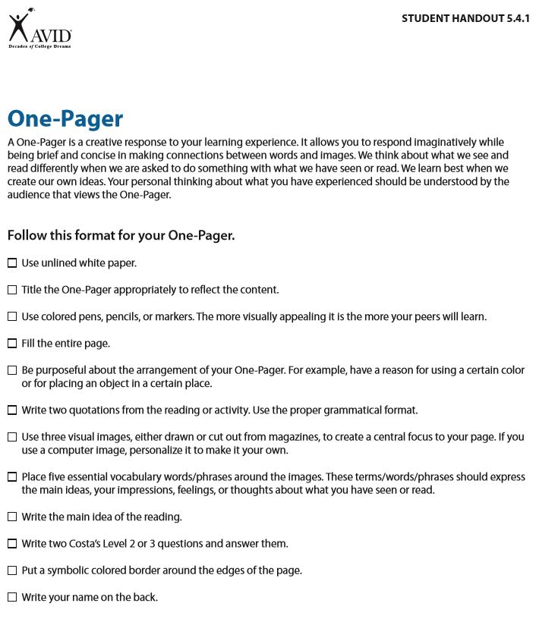

POEM/RAP/SONG
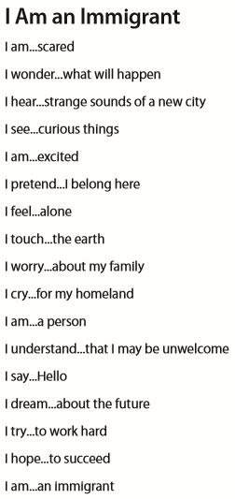
A Limerick is a humorous poem with a special rhyming pattern and stressed syllables. Limericks can be written about a variety of topics, events, places or people. Use the following poem structure to create your limerick.
Line 1: 3 stressed syllables Rhyme A
Line 2: 3 stressed syllables Rhyme A
Line 3: 2 stressed syllables Rhyme B
Line 4: 2 stressed syllables Rhyme B
Line 5: 3 stressed syllables Rhyme A
An “I Am” Poem is a poem about a person, a group of people or an inanimate object which uses the ideas of emotions and senses. Follow the template below by completing the sentences.
I am
I wonder
I hear
I see
I am
I pretend
I feel
I touch
I worry
I cry
I am
I understand
I say
I dream
I try
I hope
I am

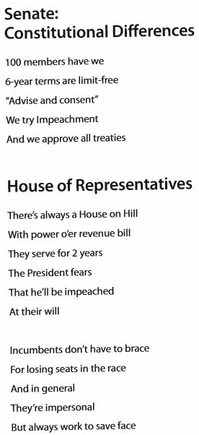

Acrostic Poems can be used to express ideas about concepts, people, or primary source materials. Students analyze and interpret a social studies topic in an acrostic poem. Print the title of the topic vertically, letter by letter, along the left margin of the page. Each letter then becomes the starting point for a word, phrase, or sentence that describes the topic.

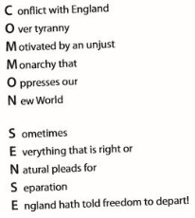

Haiku poetry invites students to describe different places or geographic regions. This writing activity promotes students to think creatively by following a specific structure. Haiku poetry is written in the following structure:
Line one: 5 syllables
Line two: 7 syllables
Line three: 5 syllables
ABC Poems can display a variety of perspectives on an event or topic. Use the letters of the alphabet to start each line of the poem. Each line may have a word or a collection of words. Continue until you come to a logical conclusion, which may end the poem prior to reaching the letter z. This type of informal poem tells a story and should have some illustrations. ABC poems can display a variety of perspectives on an event or topic.
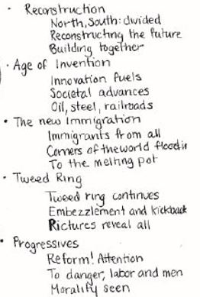
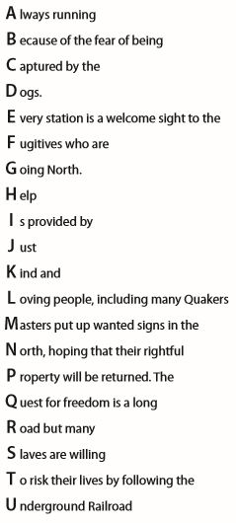

Concept Poem invites students to analyze a concept and express their interpretation through a pattern of ideas. To create a concept poem, students select a topic and then describe the topic by completing each line in the format shown below.
Concept: ____________________________
Believes in: __________________________
Needs: ______________________________
Gives: ______________________________
Takes/Fears: _________________________
Would like to see: _____________________
Is similar to: __________________________

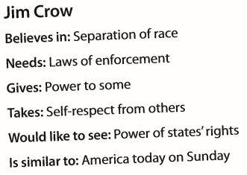

Source: AVID The Write Path Teacher Guide 6-12, History/Social Science

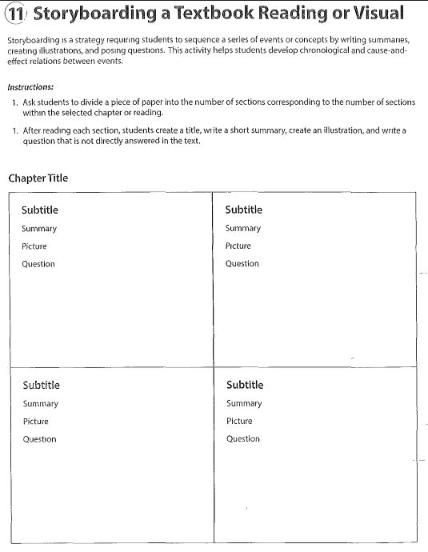

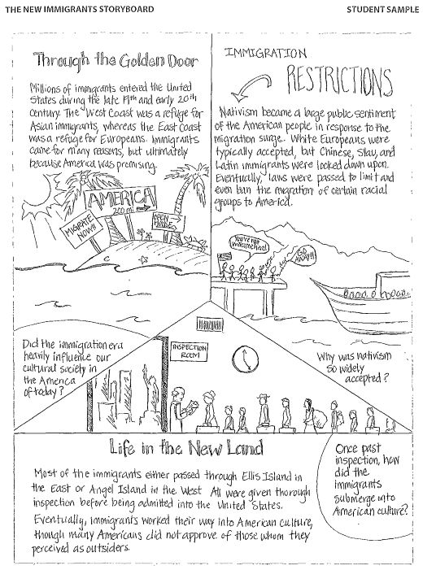

Source: AVID The Write Path Teacher Guide 6-12, History/Social Science

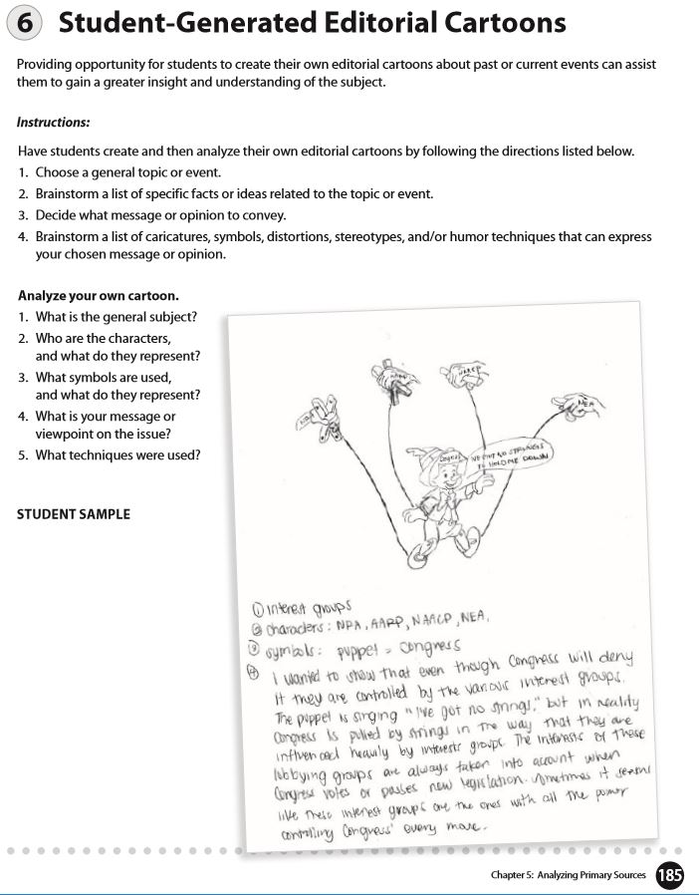
Source: AVID The Write Path Teacher Guide 6-12, History/Social Science

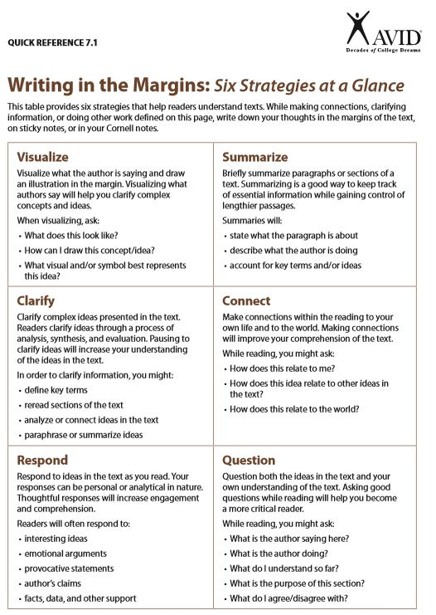

Source: AVID Critical Reading Teacher Guide 7-12

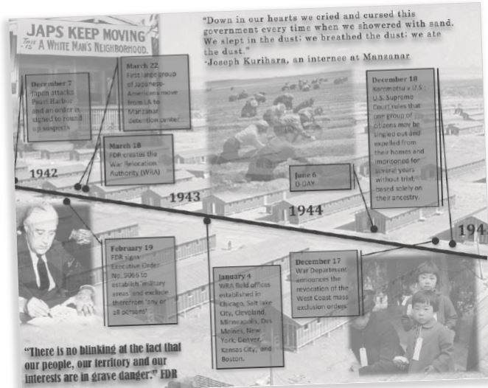Annotated Timeline

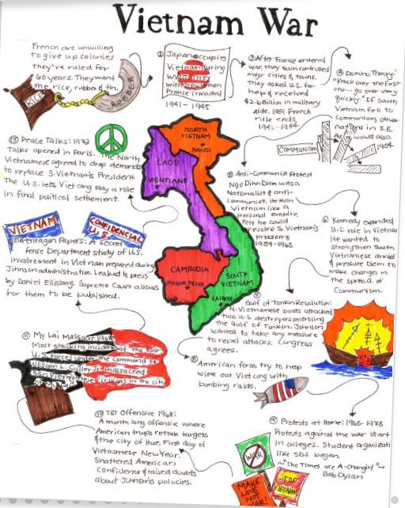

Source: AVID The Write Path Teacher Guide 6-12, History/Social Science

Graphic Organizers
Graphic organizers are a power tool for organizing information about an event, topic, or person. Organizers use words and visual symbols to clarify patterns and relationships. There are many types of organizers. The decision of which one to use depends on the purpose of the learning task.

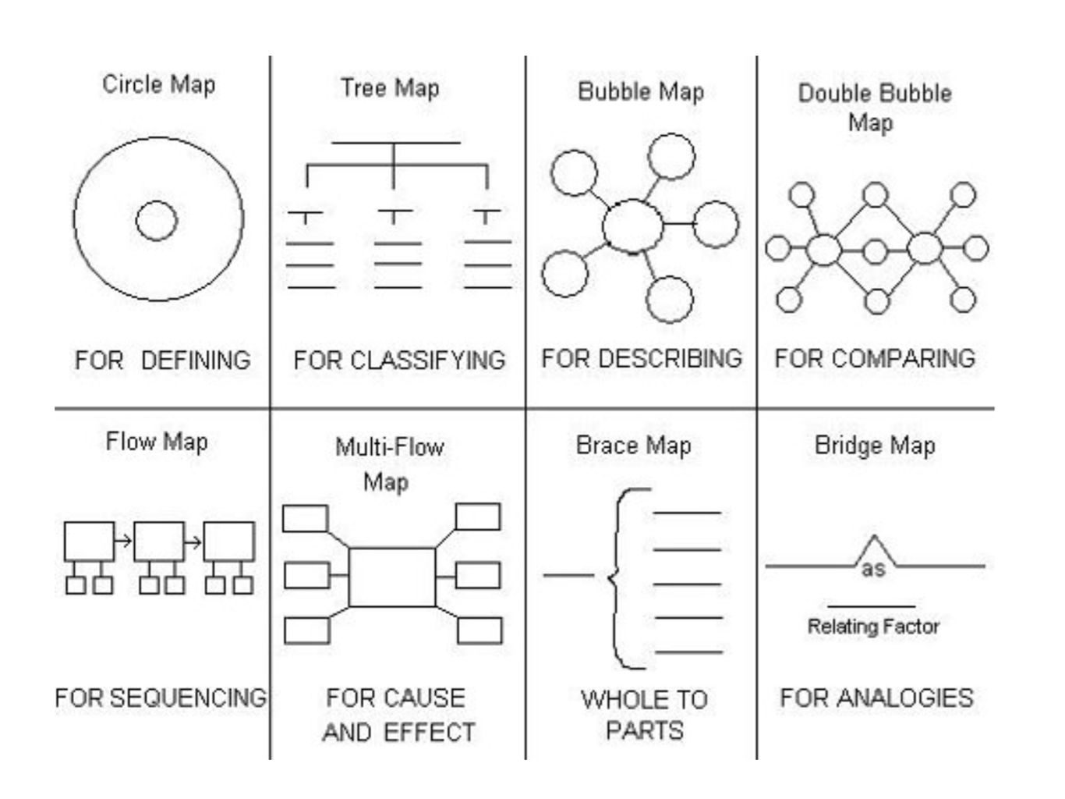

Source: AVID The Write Path Teacher Guide 6-12, History/Social Science

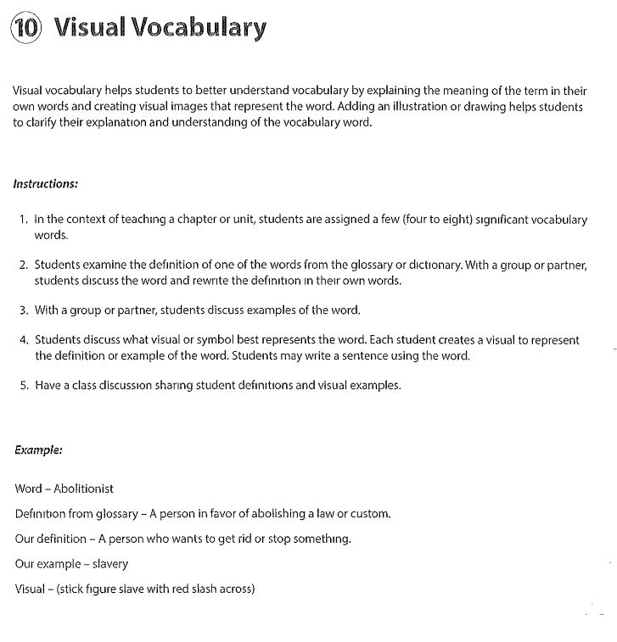

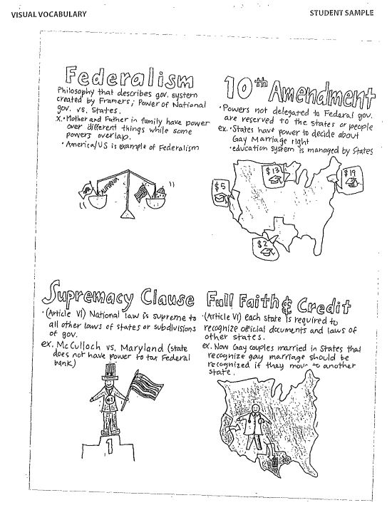

Source: AVID The Write Path Teacher Guide 6-12, History/Social Science

