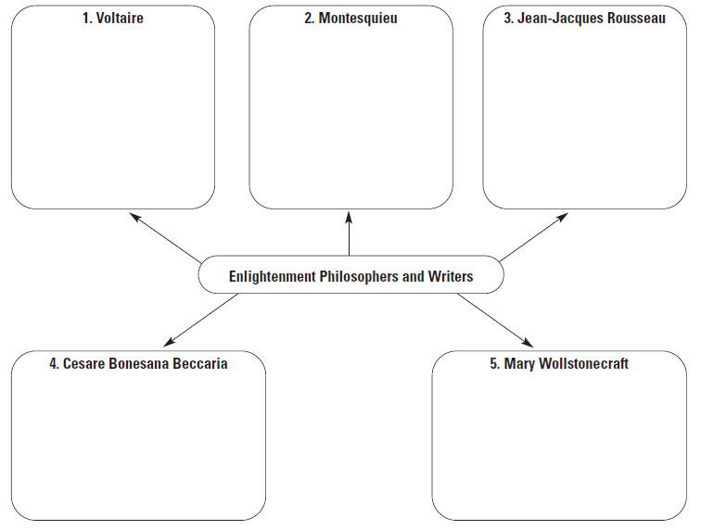

Directions: First complete the warm up writing prompt below using complete sentences. Next, take turns in your group reading the handouts I have provided on each of the six enlightenment philosophers and writers. After you read each handout fill in the appropriate piece of the graphic organizer with information on that philosopher’s beliefs. Finally, after you have completed all five parts provide a written response to the two questions below.
Warm-up: What natural rights do you believe ALL people should have?
____________________________________________________________________________________________________________________________________________________________________________________________________________________________________________________________________________________________________________________________________________________________________________________________________________________________________________________________________________________________________________________________________________
- Which Enlightenment thinker was most influential? Why?
____________________________________________________________________________________________________________________________________________________________________________________________________________________________________________________________________________________________________________________________________________________________________________________________________________________________________________________________________________________________________________________________________________
- What do you think Voltaire meant when he said “I do not agree with a word you say but will defend to the death your right to say it.”?
____________________________________________________________________________________________________________________________________________________________________________________________________________________________________________________________________________________________________________________________________________________________________________________________________________________________________________________________________________________________________________________________________________

