Important Stuff
United Nations
War Production
Cost Plus
Women in War
FDR’s Four Freedoms
Executive order 8802
Japanese Internment
Korematsu Vs. US

1 WWII Shaped the way Americans Saw themselves and wanted to be seen by the world. One thing that is certain is that the US was very (Different//Same// Weak) After the war.
“New Deal On Steroids”
Your text here
2 WWII Strengthened the federal government meaning……. U.S. had
(a More “laissez faire” hands off government ///or/// More government controls )
3. Why can you not buy a 1942 ford? ___________________________________________.
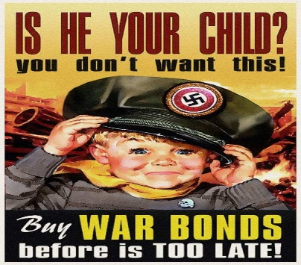
4. A whole buncha Federal spending got US out of The ________Depression. The Gov. Paid for all this by going into DEBT but also by collecting ______and selling _____ Bonds.
5. The “Cost Plus” Contracts guaranteed companies would make a profit and helped big business. (T//F)
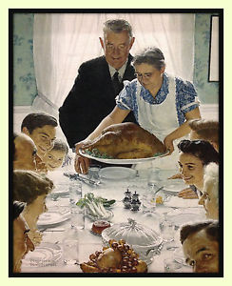
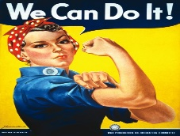
6. The Government was Pro Union During the WWII because ((FDR was a secret Communist// to prevent labor Strife and Strikes))
7. “Rosie the Riveter” was a symbol for _______________ in the workforce.
8. (True//False) Women got to keep all their high paying jobs when the war was done.
9. Franklin Delano Roosevelts 4 Freedoms Speech: Those 4 freedoms were
Freedom From Want
1 Freedom of __________ 2 Freedom of ______________
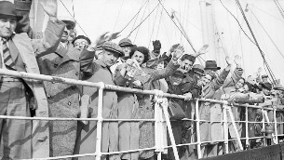
3 Freedom from _________4 Freedom From ____________
10. (True// False) The USA accepted with open arms any and all Jews fleeing the Holocaust.
11. Zoot Suit Riot was a riot in California involving ((Irish/// Mexican))
12. The Braceros Program = Circle the Quote that sums it up
“Build the Wall” or “Let’s try to get a bunch of Mexicans into the country to help with Homefront” – The Gov.
13. (T/F) Japanese people were sent to internment camps, but Japanese American Citizens dint have to go.
14. A Victory For Civil rights = 8802 (Briefly explain after the video)_______________________________________________________.
15. The Double V is Victory over Hitler and Victory over __________ in the US.
16. (yes/no) Pre-War the U.S. Was Isolationist: And after the war they defiantly Were Not isolationist ?
17. USA Becomes world leader of capitalist order= IMF = Stabilizes Currency, World bank, The ___ Becomes the worlds Money
17. The UN United Nations is established after the War……… Its like the league of nations only this time the USA joins the darn thing ((True //False))

