8-1 (page 257-264) Honors U.S. History: The 1920’s 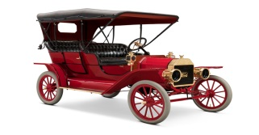
- Read “The Story Matters” on page 257 then write a 1 sentence main idea / summary of the reading.
- What Jazz musician is pictured on page 257?
- Answer the DBQ question on page 258.
- What did President Harding promise Americans when he won the 1920 election?
- What did the above promise mean?
- What was the Ohio Gang?
- Who is Charles Forbes and what did he do wrong?
- Teapot Dome Scandal - explain
- Harry Daugherty scandal - explain
- Page 261, study the cartoon and its meaning then answer question #2.
- What caused President Harding to die?
- Who became the new President after Harding’s death?
- Who was the Secretary of Treasury and what 3 goals did he want to accomplish?
- Supply-side economics - explain
- Who was the new U.S. Secretary of State?
- Isolationism - explain
- What was The Dawes Plan?
- What was the goal of the Washington Conference and the London Naval Conference?
- What was the Kellogg-Briand Pact?

