U.S History 7.2 (Pgs. 237-242)
AMERICA MOBILIZES FORWORLD WAR I 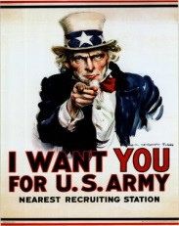
- What did the War Industries Board (WIB) do for The U.S. war effort?
- What did the Food Administration do for the war effort? Who was in charge of it?
- Explain Victory Gardens
- What did the Fuel Administration do for the US war effort?
- Provide one example of a propaganda slogan by one of these agencies.
- How much did the U.S. spend on War World I?
- What were the 2 ways the USA raised money for the war effort?
- What did the National War Labor Board accomplish?
- How many women started working during WWI? What kind of jobs did most do?
- What is “The Great Migration” and what caused it?
- Read “charts and graphs” on page 238 then study the chart. What 2 areas brought in the most money?
- What was the main job of “The Committee on Public Information”?
- What were the Four-Minute Men
- Explain Espionage with relation to WWI.
- What was the Espionage Act of 1917?
- What was the Sedition Act of 1918?
- Schenck v. United States, read page 703 and answer question #2.
- What was the Selective Service Act of 1917
- What disease killed millions worldwide during and after WWI?
- Describe African American participation in WWI.
- What was the first war that women served in the military?
- Turn to page 242, answer all 5 questions (5 points).

