Chapter 17-2: The Vietnam War (pages 506-516)
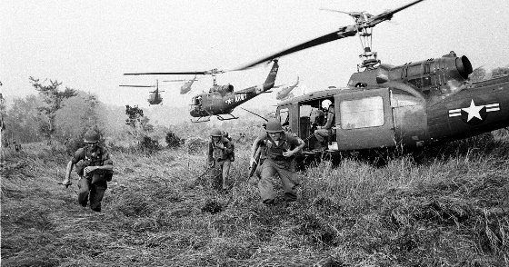
- Who was the US commander of military forces during the Vietnam War?
- What phrase/term describes Americans that did not believe or trust what our government was saying about the Vietnam War?
- What decision did Congress make giving President Johnson power to conduct the Vietnam War?
- List the 2 reasons many Americans opposed the Vietnam War.
- What is a teach-in and why did students at the University of Michigan hold a teach-in?
- What does SDS stand for and what was the goal of the organization?
- What was a very common way to avoid the Vietnam War draft?
- What groups of people were likely to serve during the war and be killed?
- What did many young American’s do when they got drafted? How many were arrested for resisting the draft?
- What did the 26th Amendment to the Constitution accomplish?
- Explain the difference between HAWKS and DOVES.
- Page 507, answer questions #1 & 2.
- Answer the RED DBQ question on page 507.
- What happened during the TET Offensive?
- Why didn’t President Johnson run for reelection in 1968?
- What 2 assassinations occurred in 1968?
- Who won the 1968 Presidential election?
- Which President began Vietnamization and what does that term mean?
- What happened at The My Lai massacre?
- Where / Why were college students killed in 1970?
- What were the “Christmas Bombings”?
- When was a peace treaty signed to end the conflict in Vietnam?
- How did The Domino Effect affect Vietnam, Laos and Cambodia?
- How many Americans died in the Vietnam War?
- Define “POW” & “MIA” as relates to the Vietnam War.
- Give details about the Vietnam Veterans Memorial.
- Explain the War Powers Act.

