Chapter 17-1: The Vietnam War (pages 497-505)
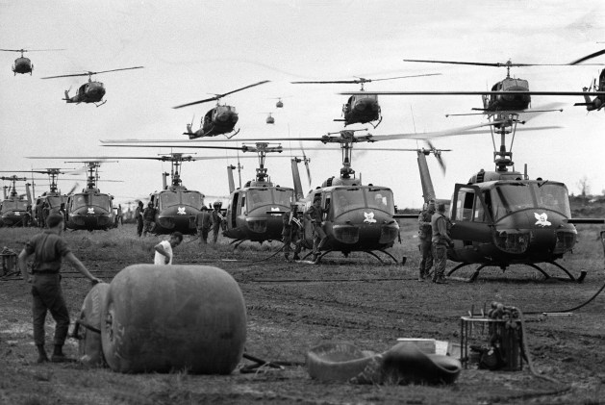
- What 3 countries controlled Vietnam before the Vietnam War started?
- What was Vietnam called when France controlled it?
- Who became the nationalist leader working for Vietnam’s independence?
- What did Ho Chi Minh call his nationalist group?
- Why did the U.S. decide to help France instead of The Vietminh?
- Domino Theory
- Guerrilla soldier
- When did the French lose Vietnam to the Vietminh?
- Geography questions page 501, # 1 & 2.
- Study the map on page 501, what country is directly North of Vietnam?
- Map page 501, what 2 countries are directly West of Vietnam?
- What decisions about dividing Vietnam were made with the Geneva Accords?
- Who became the leader of communist North Vietnam?
- Who became the leader of South Vietnam?
- When was Vietnam supposed to have elections to reunite the country?
- What was the South Vietnamese communist army called?
- What did Buddhist monks do to protest Diem’s banning of their religious flags?
- What happened to Diem?
- What happened in The Gulf of Tonkin that caused President Johnson to ask Congress if he could defend American troops in Vietnam?
- What did the Gulf of Tonkin Resolution allow?
- DBQ page 503, answer question # 1 & 2.
- What did Roy Benavidez do to receive The Medal of Honor in The Vietnam War?
- When did President Johnson begin bombing North Vietnam and send combat troops there? How many troops did he send that year?
- How did the Vietcong fight against American forces?
- What was the “Search and Destroy” method used by U.S. forces?
- What was Napalm?
- What was Agent Orange?
- What is the Ho Chi Minh Trail and what was it used for?
- What 2 countries helped Communist North Vietnam during the war?
- What is “A War of Attrition”?
- Answer the red DBQ question on page 498.

