US HISTORY: THE COLD WAR 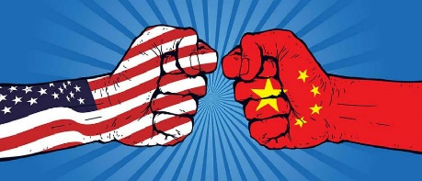
The Early Cold War Years
CHAPTER 13-2 Lessons 2 & 3 (pages 402-414) Cold War, Communism, Containment and The Red Scare
- The Long Telegram (who wrote it, what was it about?)
- Explain Containment.
- What did the Soviet Union want from Iran and how did the crisis end?
- What was the goal of The Truman Doctrine?
- How did the Truman Doctrine help fight communist aggression in Greece and Turkey?
- What is the Marshall Plan?
- Study the chart on page 404, what 3 countries received the most money from the U.S. Marshall Plan?
- Why did the Soviet Union start the Berlin Blockade?
- What was the purpose of the Berlin Airlift?
- Make a chart that describes NATO and The Warsaw Pact.
- Geography question page 405, question # 1 only. Write question and answer.
- Who led the communist revolution in China, Who was the leader of Nationalist China?
- Who and how did the USA help during the Chinese revolution?
- Critical Thinking Map page 406, answer the analyzing question.
- How did the USA help Japan after WWII?
- After WWII what was used as the dividing line between North and South Korea?
- Which side did the USA and The UN help in the Korean War?
- Which side did Communist China help during the Korean War?
- Why did President Truman fire General MacArthur during The Korean War?
- How and when did the Korean War end?
- What is The DMZ?

Lesson 3, page 410 (#22-30)
- How did the New Red Scare begin with Igor Gouzenko?
- Explain Subversion.
- What was the Loyalty Review Program?
- What was the goal of the HUAC?
- Who said there was communist in Hollywood and what is The Hollywood 10?
- What was Alger Hiss guilty of and what are “The Pumpkin Papers”?
- Explain the Rosenberg spy case.
- Explain McCarthyism.
- How did Americans prepare for potential H bomb attacks in the 1950’s?
- What was Fallout?

