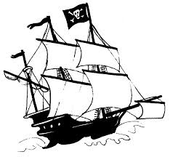
P-I-R-A-T-E-S Notes

This is a pre-reading strategy that helps you preview the chapter before going in depth. When starting a new chapter this should be done first. Find two examples for each letter in the word Pirates and thoroughly provide details about it in complete sentences.
P- Political – Anything to do with government, rulers, laws, etc.
I – Intellectual – Anything to do with new ways of thinking,
education, literature, etc.
R – Religion – Anything to do with beliefs, practices, religious law,
religious leaders, etc.
A – Arts and Architecture – Anything to do with art, building designs,
styles or techniques, etc.
T – Technology – Anything that is developed to make tasks easier,
faster, or more convenient.
E – Economics – Anything to do with the production, distribution, and
consumption of wealth
S – Social – Anything to do with the way people behave, treat one
another, divide themselves into classes, etc., as well as gender and race issues.

