Unit- Industrialization: Mini Assessment

- What was the primary goal of the Dawes Act of 1887 regarding Native American Indians?
  - Assimilating Native American Indians into mainstream American life
  - Increasing the size of Native American Indian reservations
  - Promoting Native American Indian languages and cultures
  - Strengthening Native American tribal governments

- Which proposal by the Granger movement during the 1870s attracted the support for many western farmers?
  - The money supply should be deflated by removing paper currency from circulation
  - Shipping rates and grain storage fees charged by railroads should be regulated
  - Immigrants should be given land on the Great Plains
  - The government should control the development of resources in the West

- How were the Granger movement and the formation of the Populist Party similar?
  - Both wanted to end the practice of sharecropping
  - Both wanted to improve conditions for farmers
  - Both wanted to provide housing for urban dwellers
  - Both wanted to increase profits for railroad companies

Base your answer to question 4 on the legislation below and on your knowledge of social studies.

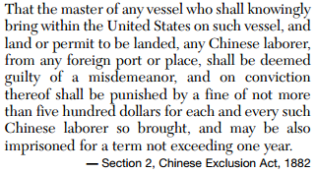

- What can the passage of this legislation be attributed to?
  - Demands by business for additional workers
  - Efforts of the American Federation of Labor to recruit skilled workers
  - Pressure from railroads to limit competition in shipping
  - Economic and race-based opposition to immigrants in the western United States

- In the late 19th and early 20th centuries, which of the following was a goal of the American Federation of Labor (AFL)?
  - End restrictions on child labor
  - Join all workers into a single union
  - Improve wages and working conditions
  - Admit women to the industrial workforce

Base your answers to questions 6 and 7 on the cartoon below and on your knowledge of social studies.

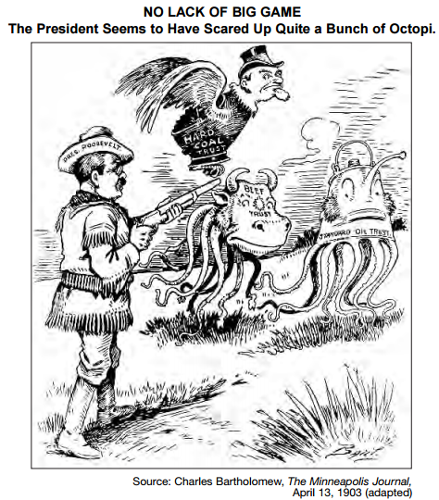

- Based on the information provided by the cartoon, what was President Theodore Roosevelt’s goal?
  - Persuade businesses to accept nationalization
  - Assist businesses in resisting interference by investors
  - Establish worker safety regulations in factories
  - Use federal power to control monopolies

- Which act of Congress gave President Roosevelt the authority that he demonstrates in this cartoon?
  - Meat Inspection Act
  - Sherman Antitrust Act
  - Underwood Tariff Act
  - Pure Food and Drug Act

- What was the term muckraker used to describe during the Progressive Era?
  - Dissatisfied workers who went on strike
  - Northerners who went South following the Civil War
  - Investigative journalists who exposed societal problems
  - Women who supported the Prohibition movement

Base your answer to question 9 on the passage below and on your knowledge of social studies.

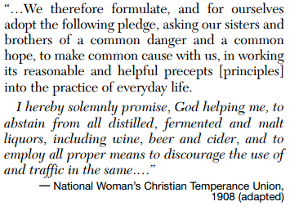

- According to the passage, what did those who adopted this pledge believe?
  - Religion had no place in national politics
  - Congress should repeal Prohibition
  - Alcohol consumption was damaging to society
  - Only the government can solve social problems

Base your answer to question 10 on the cartoon below and on your knowledge of social studies.

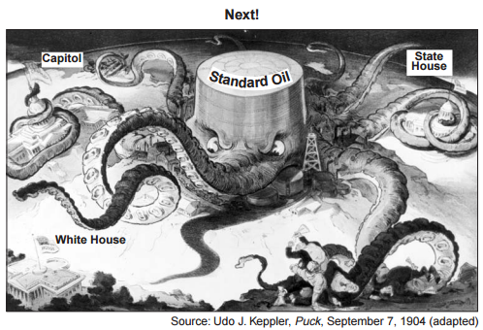

- What is the principal message of the cartoon regarding the Standard Oil Company?
  - Used its size to lower the prices of its products
  - Protected the nation from foreign competition
  - Used its economic power to influence government decisions
  - Employed violence to gain an unfair advantage for its workers

