Unit- Civil War and Reconstruction: Mini Assessment

- What was a common goal of the 13th, 14th, and 15th amendments to the United States Constitution?
  - Punishing the South for seceding from the Union
  - Granting basic rights to formerly enslaved persons
  - Allowing the states to veto federal laws
  - Creating a “separate but equal” society

Base your answer to question 2 on the excerpt below and on your knowledge of social studies.

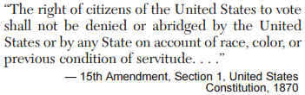

- Which actions did Southern States take to keep African Americans from exercising the rights guaranteed in this amendment?
  - Suspending habeas corpus and denying women the right to vote
  - Collecting poll taxes and requiring literacy tests
  - Establishing religious and property-holding requirements for voting
  - Passing Black Codes and establishing segregated schools

- Why did the Radical Republicans in Congress oppose President Abraham Lincoln’s plan for Reconstruction?
  - Because it called for the imprisonment of most Confederate leaders
  - Because it planned to keep Northern troops in the South after the war
  - Because it rejected the idea of harsh punishments for the South
  - Because it demanded immediate civil and political rights for formerly enslaved persons

- After the Civil War, why did freedmen in the South have difficulty improving their economic conditions?
  - Literacy for former enslaved persons was prohibited
  - Migration of factory workers from Northern cities had created competition for jobs
  - The federal government confiscated their 40-acre grants
  - The system of sharecropping kept them in a cycle of poverty

- Why were Black Codes established in the South immediately after the Civil War?
  - Integrate freedmen into American society
  - Enforce the Emancipation Proclamation
  - Expand educational opportunities
  - Limit the rights of newly freed African Americans

- After the Civil War, which of the following was a significant cause of conflict between President Andrew Johnson and the Radical Republicans in Congress?
  - The plans for restoring Southern states to the Union
  - A proposal to repeal the Emancipation Proclamation
  - Reduction of the army and the navy to prewar levels
  - Congressional efforts to pay the Confederate war debt

- Which heading best completes the partial outline below?

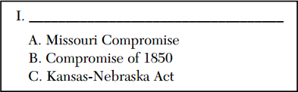

  - Rise of Sectionalism
  - Impact of Industrialization
  - Examples of Religious Revivalism
  - Events Leading to the Mexican War

- Which term refers to the idea that settlers had the right to decide whether slavery would be legal in their territory?
  - Nullification
  - Sectionalism
  - Popular sovereignty
  - Southern secession

Base your answer to question 9 on the passage below and your knowledge of social studies.

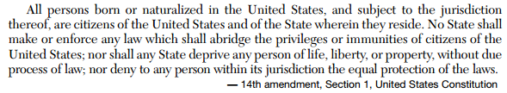

- What was the primary reason for the adoption of this amendment in 1868?
  - Protect the rights of formerly enslaved persons
  - Make it easier for immigrants to become citizens
  - Extend suffrage to settlers on the Great Plains
  - Require the federal government to pay the costs of Reconstruction

- As the Civil War ended, which action was supported by President Abraham Lincoln and the Radical Republicans?
  - Abolishing the institution of slavery by a constitutional amendment
  - Passing Black Codes to guarantee equality for formerly enslaved persons
  - Putting confederate leaders on trial for war crimes
  - Ending the military occupation of the South immediately

