U.S. History 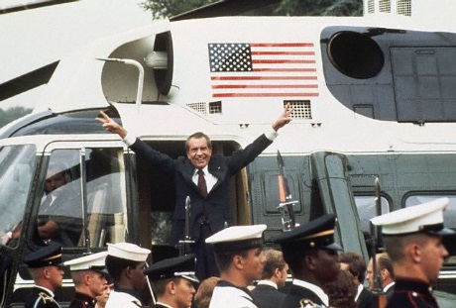
Ch. 19.1 President Nixon and the 1970’s (page 540)
- Who was “The Silent Majority”?
- What was the goal of “The Southern Strategy”?
- Geography Connection page 541, answer question # 1 & 2.
- Who became the new Chief Justice of the Supreme Court after Earl Warren retired?
- Explain: New Federalism
- Define: Revenue Sharing
- Who became Nixon’s National Security Advisor?
- Explain: Vietnamization
- Why was The Soviet Union unhappy with Nixon as US President?
- What was Nixon’s idea of détente
- When did Nixon visit China and what was accomplished?
- Define: Summit
- Who was the new Soviet leader when Nixon visited Moscow?
- What were the agreements outlined in the Strategic Arms Limitation Treaty (SALT I)?
- What were the agreements of the Helsinki Accords?
Ch. 19.2 Watergate (page 545)
- What incident did Washington Post reporter Bob Woodward investigate and report on?
Who was the other reporter that worked with Woodward?
- Who was Nixon’s democratic opponent in the 1972 election?
- Why did Nixon advisors order the break in of the Democratic Party headquarters at the Watergate building?
- Who paid the burglars to commit the crime?
- Who was the secret informer for The Washington Post story?
- Who was it that ordered the Watergate break in?
- What was Nixon accused of in The Watergate break in?
- Why were the White House tapes so important?
- Why did President Nixon refuse to hand over the tapes?
*Also define-Executive Privilege
- Who did Nixon try to fire and why?
- What happened to Nixon’s VP?
- Page 547 questions # 1 & 2 on USA v. Nixon.
- What impeachment charges were brought against President Nixon?
- What did President Nixon do on 8/9/74?
- Who became the new President and what did he do for Nixon?

