Civilian Conservation Corps
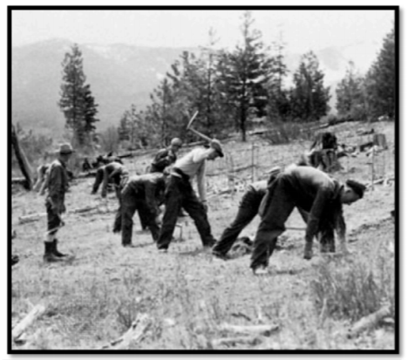
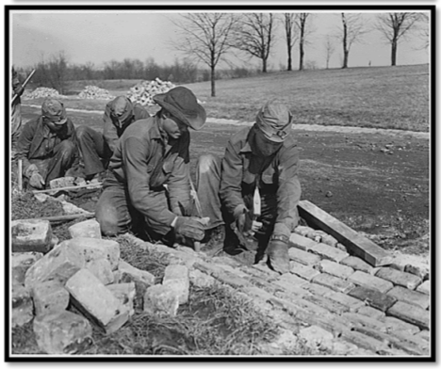
The environmental program put 2.5 million unmarried men to work maintaining and restoring forests, beaches, and parks. Workers earned only $1 a day bur received free board and job training. From 1934 to 1937, this program funded similar programs for 8.500 women. The CCC taught the men and women of America how to live independently, thus increasing their self-esteem.

Works Progress Administration (WPA) 1933
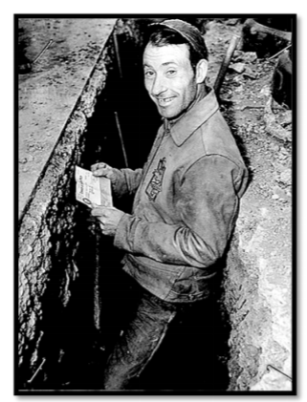
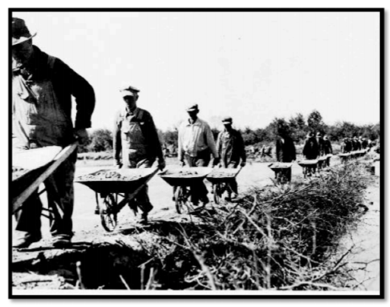
This agency provided work for 8 million Americans and attempted to decrease unemployment. The WPA constructed or repaired schools, hospitals, airfields, etc. WPA had employed more than 8,500,000 different persons on 1,410,000 individual projects, and had spent about $1.1 billion. During its 8 year history, the WPA built 651,087 miles of highways, roads, and streets; and constructed, repaired, or improved 124,031 bridges, 124,110 public buildings, 8,192 parks, and 853 airport landing fields.

Agriculture Adjustment Administration (AAA) 1933
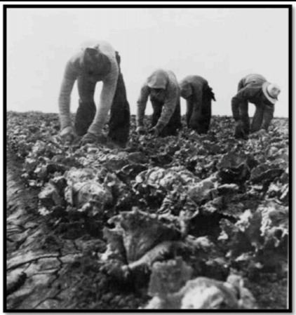
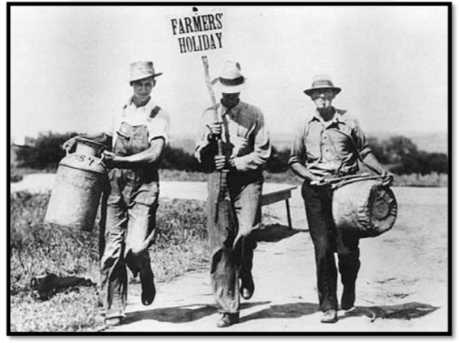
The AAA tried to raise farm prices. It used proceeds from a new tax to pay farmers not to raise specific crops and animals. Lower production would, in turn, increase prices. Farmers killed off certain animals and crops as they were told by the AAA. Many could not believe that the federal government was condoning such an action when many Americans were starving. This was declared unconstitutional later on.

National Industrial Recovery Act (NIRA) 1933
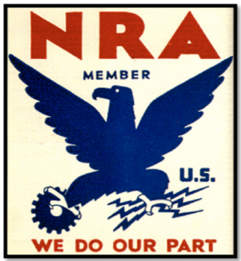
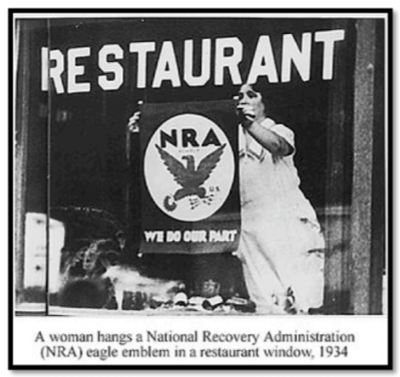
The decline in the industrial prices in the 1930s caused business failures and unemployment. The NIRA was formed in order to boost the declining prices, helping businesses and workers. The NIRA also allowed trade associations in many industries to write codes regulating wages, working conditions, production, and prices. It also set a minimum wage. The codes stopped the tailspin of prices for a short time, but soon, when higher wages went into effect, prices rose too. Thus, consumers stopped buying. The continuous cycle of overproduction and under consumption put businesses back into a slump. Some businesses felt that the codes were too complicated and the NRA was too rigid. It was declared unconstitutional later on.

Federal Deposit Insurance Corporation
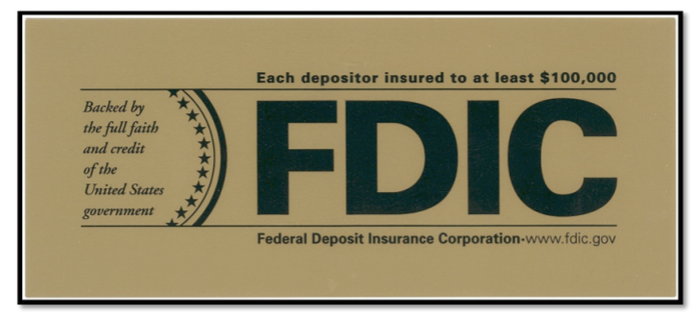
The Federal Deposit Insurance Corporation (FDIC) was formed by Congress to insure deposits up to $2500. Insured institutions are required to place signs at their place of business stating that "deposits are backed by the full faith and credit of the United States Government." Since the start of FDIC insurance on January 1, 1934, no depositor has lost a single cent of insured funds as a result of a failure.

Social Security Act
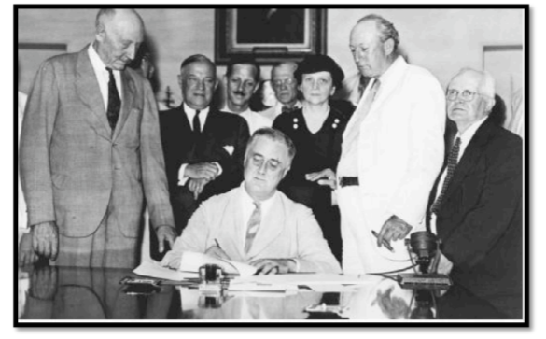
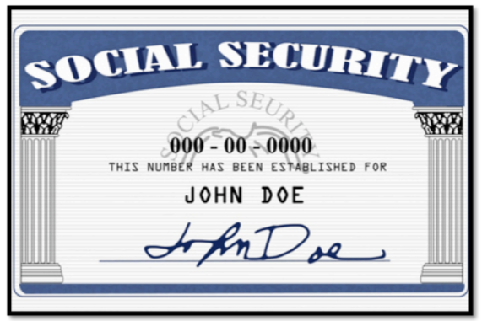
This act established a system that provided old-age pensions for workers, survivors benefits for victims of industrial accidents, unemployment insurance, and aid for dependent mothers and children, the blind and physically disabled. Although the original SSA did not cover farm and domestic workers, it did help millions of Americans feel more secure.

Securities and Exchange Commission (SEC) 1934
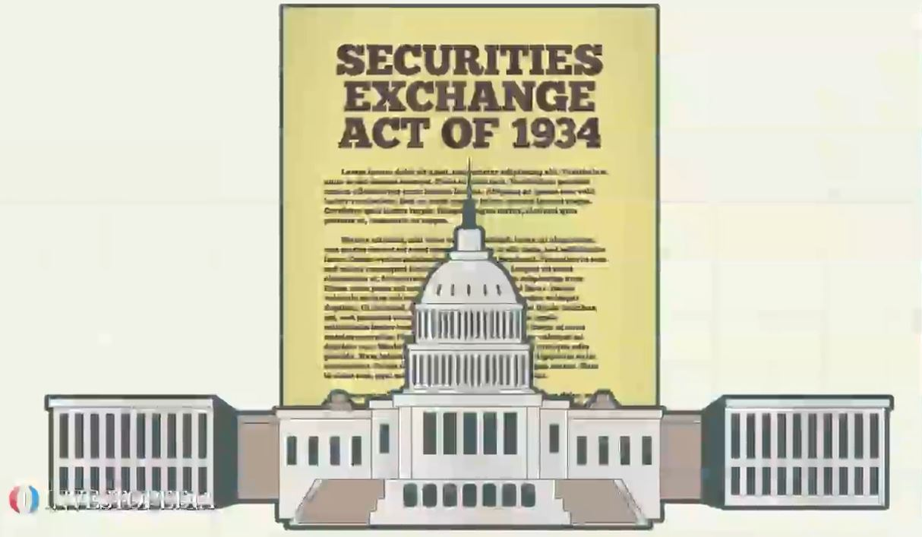
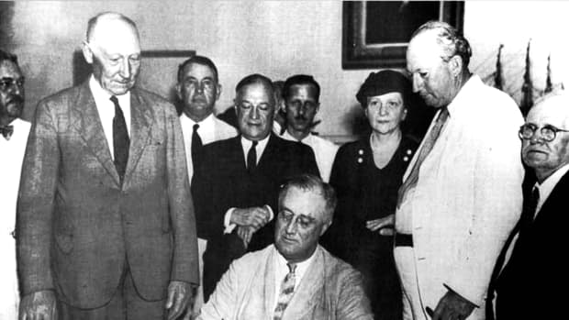
The Securities and Exchange Commission was created in 1934 to regulate the stock market and to restore investor confidence. It ended misleading sales that led to the collapse of the stock market in 1929. It also set rules that companies must follow when issuing stock.

Tennessee Valley Authority (1933) TVA

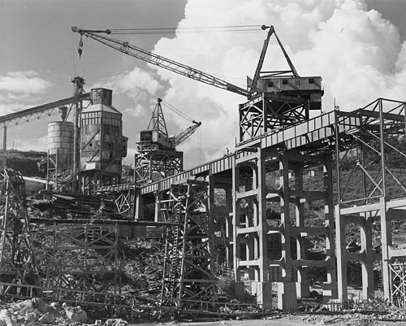
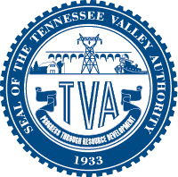
The Tennessee Valley Authority was established in 1933 as one of FDR’s Deal programs. Its goal was to provide jobs and electricity to the rural Tennessee River Valley, an area that spans seven states in the South. The TVA was given authority to purchase land along the Tennessee River to build dams, reservoirs, and power plants. The TVA Act encouraged economic development and provided jobs by bringing electricity to rural areas for the first time.

New Deal Public Programs
Relief? Recovery? Reform?
In your group, read and review your assigned program. Answer the following questions in complete sentences. Be prepared to share with the rest of the class.

New Deal Program Name: _______________________________________________________

FDR’s New Deal Programs were designed to meet the following needs:
- Relief‐ to provide Americans with immediate assistance to help them with basic necessities of life, including food, direct monetary payments and employment
- Recovery‐ A policy or program that has its primary goal to promote growth in the American economy
- Reform‐ A policy or program that was designed to ensure that effects of the Great Depression did not occur again.

- Who was the program intended to help?

- What was this program intended to do?

- Does this program fall under the Relief, Recovery, or Reform Program of Roosevelt’s New Deal? Explain.

New Deal Remedies
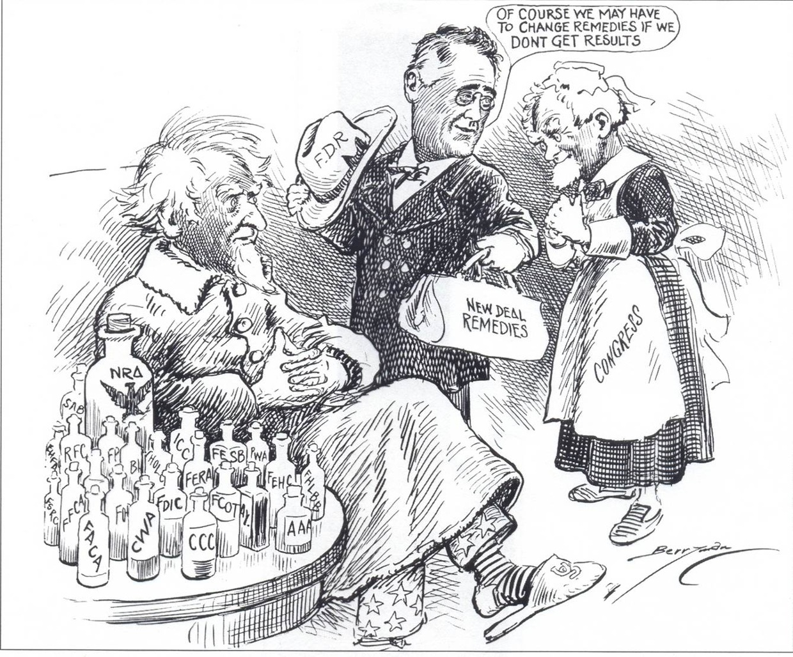
- Who are the three people depicted in this cartoon? How do you know who they are?

- What do the bottles on the table represent?

- How is Roosevelt shown in this cartoon?

- Do you think this cartoon is positive or negative toward the New Deal programs of FDR?

