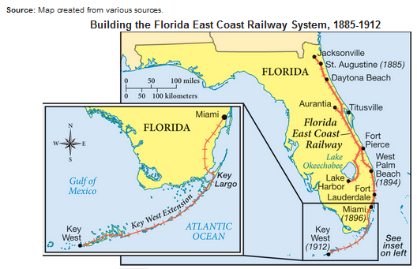
U.S. History (A.3.13) Examine key events and people in Florida history as they relate to US history.
Map of the Florida East Coast Railway

Discussion Questions: Turn-&-Talk
- During what years did Flagler build his railroad system from Jacksonville to Miami?
- When did the extension reach the city of Key West?
- How might each of the following businesses in South Florida be helped by Flagler’s railway?
  - Orange Groves
  - Home Builders
  - Fishing Guides
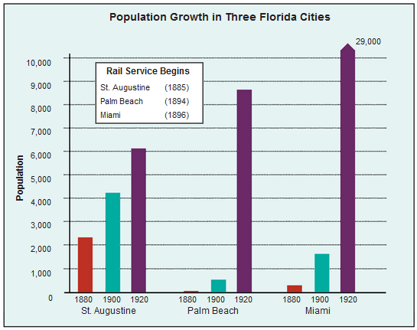
There had been almost no railroad construction in Florida since the end of the Civil War. The rail lines that did exist had been built without regulation and with no regard to consistency. With construction underway on the grand Hotel Ponce de Leon in St. Augustine, Henry Flagler realized he was in dire need of better transport from Jacksonville (the southern rail hub). So, he ponied up half a million dollars and bought the railroad. Convinced he was onto something, he set out to provide uninterrupted train service for tourists visiting Florida.
By the early 1900s Flagler had invested nearly $50 million dollars in Florida, secretly donating money to build ten churches, three hospitals, and a number of schools. Flagler also sold land cheaply to orange, grapefruit, and lemon grove owners.
Based on the information above, what relationship did the railroads have with the growth of Florida’s east coast cities? Cite your evidence.

Population Growth in 3 Florida Cities

Discussion Questions: Turn-&-Talk
- What is the approximate population of St. Augustine in 1880, 1900, and 1920?
- What generalization can you make about the population of these three cities?
- Could there be a possible connection between the growth of these three cities and Flagler’s railroad?

U.S. History (A.3.13)
Teacher Notes:
Benchmarks:
- Examine key events in Florida history as it relates to United States history. (A.3.13)
- Analyze how images, symbols, objects, cartoons, graphs, charts, maps, and artwork may be used to interpret the significance of time periods and events from the past. (A.1.4)

Clarification: Students will recognize the impact of Henry Flagler and the completion of the Florida East Coast Railroad on the development of the Florida Gold Coast.
Related Concepts: Second Industrial Revolution, Industrial developments, Entrepreneurs, increase of urbanization
Map Background Information
The Florida East Coast Railway 1885-1912
- The Florida East Coast Railway connected Jacksonville to Key West and was constructed from 1885-1912.
- Flagler saw the potential for Florida to become both a tourist destination and a waypoint for Caribbean and Latin American ocean traffic. He needed a complete railway for cargo and tourists to reach his developments, like his hotels, and continue south.
Graph Background Information
Population Growth in 3 Florida Cities
- Every city connected to Flagler’s railroads saw huge booms in construction, jobs, and amenities. He took advantage of this with his hotels, farming subsidies, and development of entertainment venues along the beaches. He also built hospitals, roads, schools, and churches to ensure his tourists and employees would have high standard of enjoyment, health and easy access to his properties.
- Flagler often bought land cheaply alongside the railroad and then later donated the land back to the cities to ensure development of infrastructure and to entice people to move there.
- The 1920 Miami bar in the graph could be misleading. Having the “cut-off” might make a difference. Extending the column to full height, students can see the full impact of Miami’s growth as a consequence of Flagler’s influence.

