Crash Course WWII Part 1
Topics Covered In This Video
- Battan Death March
- Midway Island
- Manhattan Project
- Atomic Bomb
- American Isolationism
- Neutrality Act
- Lend Lease
- Cash and Carry
- Island Hopping
- “Arsenal of Democracy
- America 1st

After WWI American people “shy” wanted to get involved in the affairs of foreign countries.
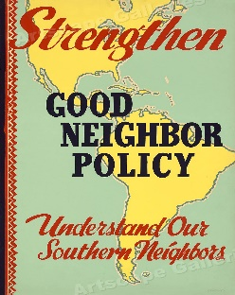
Time period from 1920 to WWII period is often called an age of (isolationism// Expansionism) In America.
The Good Neighbor policy was less interventions in (Latin America/// China)
- Japan Invades China.
- Italy Invades Ethiopia
- Fascist Dictators come to power in Spain, Italy and Germany.
The U.S. Responds to the Events Above by passing the (Isolation Acts/// Neutrality Acts)
The _____________ Acts banned the sale of Arms to Belligerent Countries. AKA Fighting countries.
A group called (America 1st// America 2nd //America Heck yeah) Cautioned against getting involved in Foreign Affairs.
FDR wanted to help the British (True//False) even though most people were pro staying out of the war!!!
Cash and Carry = Meant that the British had to pay for weapons in ___________ not credit. And they had to _____________ them across the Atlantic themselves.
Arsenal of Democracy
Lend Lease Act = Gave Military Aid to countries…
(For Free // Who promised to pay it back // Who had dictatorships)
Lend lease gave Military stuff to England and (USSR // Germany)
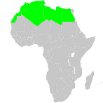
The U.S. Stagey in the pacific is called__________________. Which involved taking Japanese controlled islands one by one and using them as bomber bases.
The First place US Troops got to KILL SOME NAZIs was (North Africa// Normandy France)
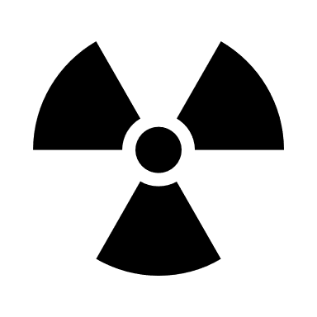
Ernie Pile was a (war correspondent+ Writer// General).
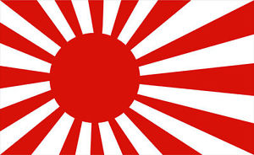
The Manhattan Project developed the ________________ bomb
The Atomic Bomb was dropped on What country?__________________.
(TRUE// FALSE) Targeting civilians was considered okay under a TOTAL WAR

