US HISTORY: WW II
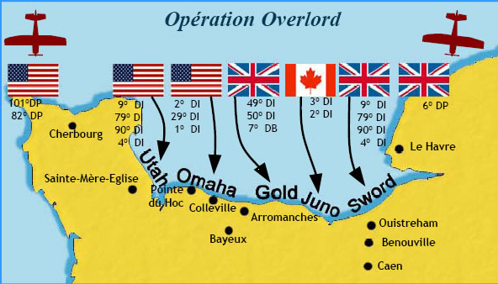
12-2 / lesson 2 & 3 (Page 367-380) The USA fights in WW II.
- Who was the U.S. Naval Commander in the Pacific during WWII?
- Who was the leader of the American forces in the Philippines islands?
- Explain what happened on the Bataan Death March.
- What was The Doolittle Raid?
- How did code breakers in Hawaii help the U.S. against Japan in the Pacific?
- Complete the Geography questions #1 & 2, page 370.
- Why was the Battle of Midway Island the turning point in the war in the Pacific against Japan?
- Explain the Island-Hopping strategy of the U.S.
- Complete Geography question #2 only page 371.
- What happened at The Battle of Leyte Gulf
- What is a Kamikaze?
- How many Japanese were killed in the US invasion to retake the Philippines Islands?
Lesson 3 page 374 (#13-25)
- What German General was in charge of the Afrika Korps?
- When-what date did the US defeat Germany in North Africa?
- How did Americans protect the US East coast from German submarines?
- What was the Convoy system?
- Explain what happened during the Battle of Stalingrad.
- Geography questions Page 377, #1 & 2.
- Who attended the Tehran Conference and what was discussed?
- What was Operation Overland?
- Who was the US commander of Operation Overlord?
- What was the goal of D-Day and when did it take place?
- How many ships and soldiers took place in D-Day?
- Where would D-Day take place?
- How many Americans died at D-Day? Where was the fighting the toughest?

