US HISTORY: WORLD WAR II
CHAPTER 11-3 THE HOLOCAUST 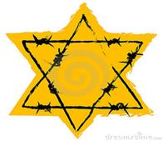
Directions: read pages 344-351 and answer the questions below.
- How many Jews did the German Nazi’s kill during the Holocaust?
- Define: Shoah
- What is Genocide?
- Who else did the Nazis dislike and oppose besides the Jews?
- Nuremberg Laws (when-what)
- How were Jews identified in Germany?
- Why did so many of Germany’s Jews become unemployed?
- Kristallnacht (what-why)
- What was the Gestapo?
- What did many Jews do after Hitler came to power?
- Why couldn’t many Jews immigrate into the USA?
- What happened at The Wannsee Conference?
- What is the difference between a Concentration Camp and an Extermination Camp?
- Geography Connection Question page 348 #1 & 2. Write the question and answer for each.
- What was “The Final Solution”?
- Name 3 major extermination camps.
- How was the killing carried out at the extermination camps?
- Read page 350-351 and answer questions #1 and 5 only.

