US HISTORY: WORLD WAR II UNIT Name/period__________________
CHAPTER 11-2 The USA is drawn into WW II (pages 339-343): 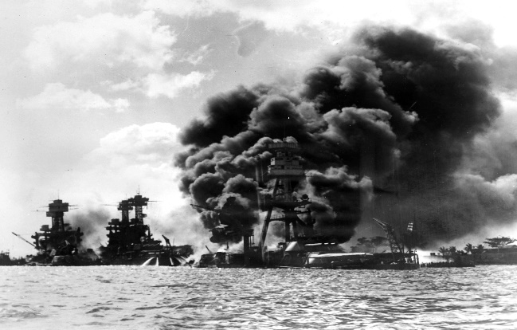
Directions: Read lesson 2 of chapter 11 and answer the questions below on your own paper, staple to the back of this sheet.
- Why did American’s support isolation and neutrality at the beginning of WWII?
- What was the subject of the Nye Committee?
- Explain the Neutrality Act of 1935.
- What nation in Africa did Mussolini invade and conquer?
- Explain the Neutrality Act of 1936.
- Who gained power in Spain after leading a Civil War?
- Explain the Neutrality Act of 1937 “Cash and Carry”
- Political Cartoon page 340, answer question 1 & 2. You must write each question and underline your answer.
- What is Internationalism?
- Explain the Neutrality Act of 1939 “Cash and Carry”
- What was involved in the Naval Destroyers “battleships for bases” trade deal with Britain?
- What was the Fight For Freedom Committee?
- What was the America First Committee?
- After Franklin D. Roosevelt won reelection as President in 1940 what 4 Freedoms did he say the USA would support?
- Explain the Lend-Lease Act.
- How did FDR deal with the German submarine attacks in the Atlantic Ocean?
- What happened at the meeting -The Atlantic Charter, with F.D.R. and Britain’s leader Winston Churchill?
- What happened to the American navy ship The Reuben James?
- Why did The USA place an EMBARGO on the sale of oil, metal and fuel to Japan?
- Why did FDR freeze Japanese money in the USA?
- Why didn’t the USA worry about Japan attacking Pearl Harbor, Hawaii?
- On what day did the Japanese carry out the surprise attack on the Pearl Harbor Naval Base in Hawaii?
- What losses did the USA suffer after the attack on Pearl Harbor (to the men and Navy ships)?
- What did FDR do after the attack on Pearl Harbor?
- What did Germany and Italy do after the Pearl Harbor attack?
- DBQ Question page 332- the RED box. Read/study pages 332-333 and answer the DBQ question in the RED Box.

